Proposal writing sucks. But it doesn’t have to suck.

Before I learned this system I used to hate writing proposals.

In highschool I was a C student in English, I didn’t like reading or writing.

When I got to college that didn’t change much, I got a C in technical writing class.

But when it comes to government proposals I can crank out these amazing well crafted documents that win me and my clients tens of millions of dollars in federal contracts every time.

Yes there are plenty of contracts that don’t require proposals, but the ones that make you money and help you build a solid business ALL will require a technical write up.

Like most things once you master this skill, you won’t have to exclude yourself from major opportunities any longer.

My name is Eric Coffie and before podcasting I built a 7 figure government contracting business in construction. Since then I’ve come on YouTube to share my thoughts and ideas of how to build a government contracting business from scratch. I’ve helped thousands of entrepreneurs scale at winning 6 and 7 figure government contracts and I want to help you too.

In the new America First era federal dollars are moving away from what certifications you have and more towards what you can do for your country.

In one of my whatsapp groups someone literally wrote this
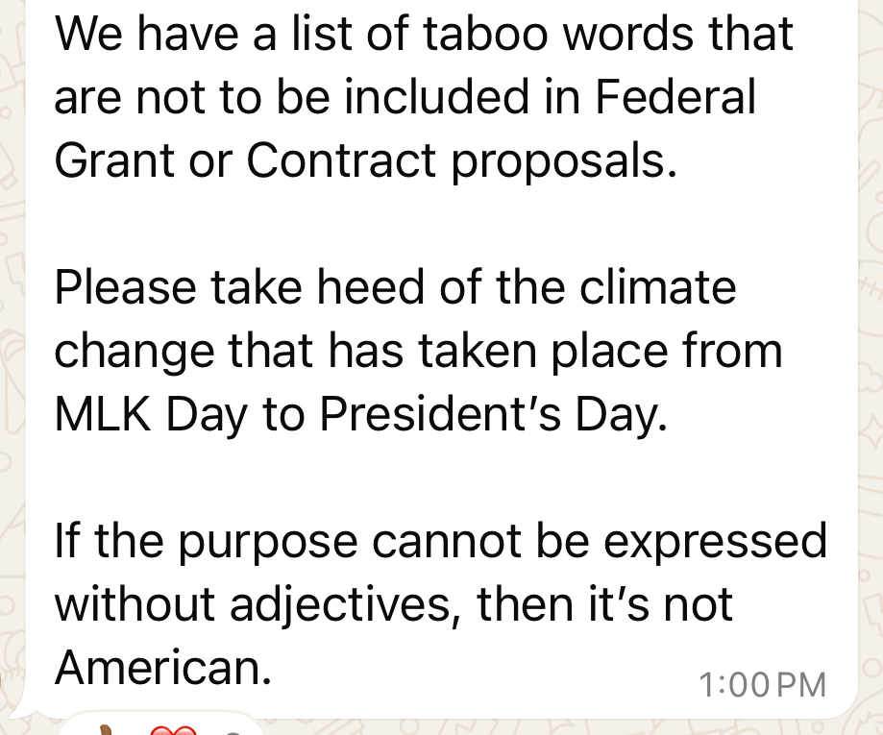

“If the purpose cannot be expressed without adjectives than it is not American“

RIght now it is more important than ever to Compete on Strength, Not Set-Asides –

Success in federal contracting depends on 3 things.
performance,
pricing, and
capability.

In this video I am going to give you 6 steps that I use to build world class proposals that win us millions in federal contracts.

“ By the way if you’re interested we have a proposal writing bootcamp starting next month. Visit govconcoaching.com for more information. You won’t just learn the theory; you’ll walk away with real, polished proposals ready for submission.” By the end of 5 weeks you will have submitted 2 Fully-Compliant, Competitive Proposals.

Let’s go.
[Sample video: 7 Habits of Millionaires - That Most People Learn Too Late]

Six Steps to Crafting World Class Proposals
Step 1: Check for qualifications
Step 2: Review Requirements
Step 3: Past Performance References
Step 4: Assign roles and responsibilities
Step 5: Review Meetings
Step 6: Cross Reference Final Draft versus Requirements
Final: Hit Send

- The first thing I do is make sure I have the qualifications to bid (Past Performance, Financials) - Instructions / Evaluations
- Once I determine that, I put the entire RFP in my Learning Model (Chat, Gemini, Ask Alpha) the whole document (you can copy and paste if necessary) and I tell it to make a list of all the statements that follow the words shall or must
  - It looks something like this “Write out a list of shall and must from this document”
  - You want to make a chart of those things so you don’t miss any requirements https://chatgpt.com/canvas/shared/67b27689dde4819190297b34aff162c4
- The 2nd thing I do is I make sure to see if I need PPQ references sent directly to government officials. NAVFAC_PPQ.pdf

- Assign each team member their responsibility with the chart of shall / must, Instruction for Offerers and Evaluation Criteria. Attch 1 - Instruction to Offerors Supplemental 25R0003.docx
  - For us we have
      - Estimators (Price and timeline)
      - Technical Writers (normally based on trade)
      - Reviewers
      - Proposal Manager
- We have periodically review meetings throughout up until the due date
  - This is what our chart looks like: roles and responsibilities.
  - Once it’s ready we have someone review the final draft

Lesson learned: date was past requirement date

- We have a proposal manager who is assigned to hit the submit button or get it out the door
  - Make sure to get proof of submission
  - Story time of late submission

Six Steps
Step 1: Check for qualifications
The first thing I do is make sure I have the qualifications to bid
(Past Performance, Financials)

Instructions
Evaluations

Step 2: Review Requirements

Once I determine that, I put the entire RFP in my Learning Model (Chat, Gemini, Ask Alpha) the whole document (you can copy and paste if necessary) and I tell it to make a list of all the statements that follow the words shall or must

“Write out a list of shall and must from this document”
  - It looks something like this
https://chatgpt.com/canvas/shared/67b2773fce4881918d9eb52090830d5d
  - You want to make a chart of those things so you don’t miss any requirements
List of "Shall" Statements in the PWS with Technical Descriptions:

Step 3: Past Performance References

The 2nd thing I do is I make sure to see if I need PPQ references sent directly to government officials.

NAVFAC_PPQ.pdf

Step 4: Assign roles and responsibilities

Assign each team member their responsibility with the chart of shall / must, Instruction for Offerers and Evaluation Criteria. Attch 1 - Instruction to Offerors Supplemental 25R0003.docx
  - For us we have
      - ESTIMATORS (PRICE AND TIMELINE)
      - TECHNICAL WRITERS (NORMALLY BASED ON TRADE)
      - REVIEWERS
      - PROPOSAL MANAGER

Kickoff Template

Step 5: Review Meetings

We host periodic review meetings weekly/bi-weekly up until the due date
  - This is what our chart looks like roles and responsibilities.

Navfac Proposal Schedule
Compliance Matrix

Step 6: Cross Reference Final Draft versus Requirements

Once it’s ready we have someone review the final draft
Lesson learned: timeline graph was past requirement timeline

Finally
We have a proposal manager who is assigned to hit the submit button or get it out the door
  - Make sure to get proof of submission
  - Story time of late submission

